Simple Python installing instructions

# Go to Python website by clicking the following: [www.python.org](http://www.python.org).

You should see something like the following:

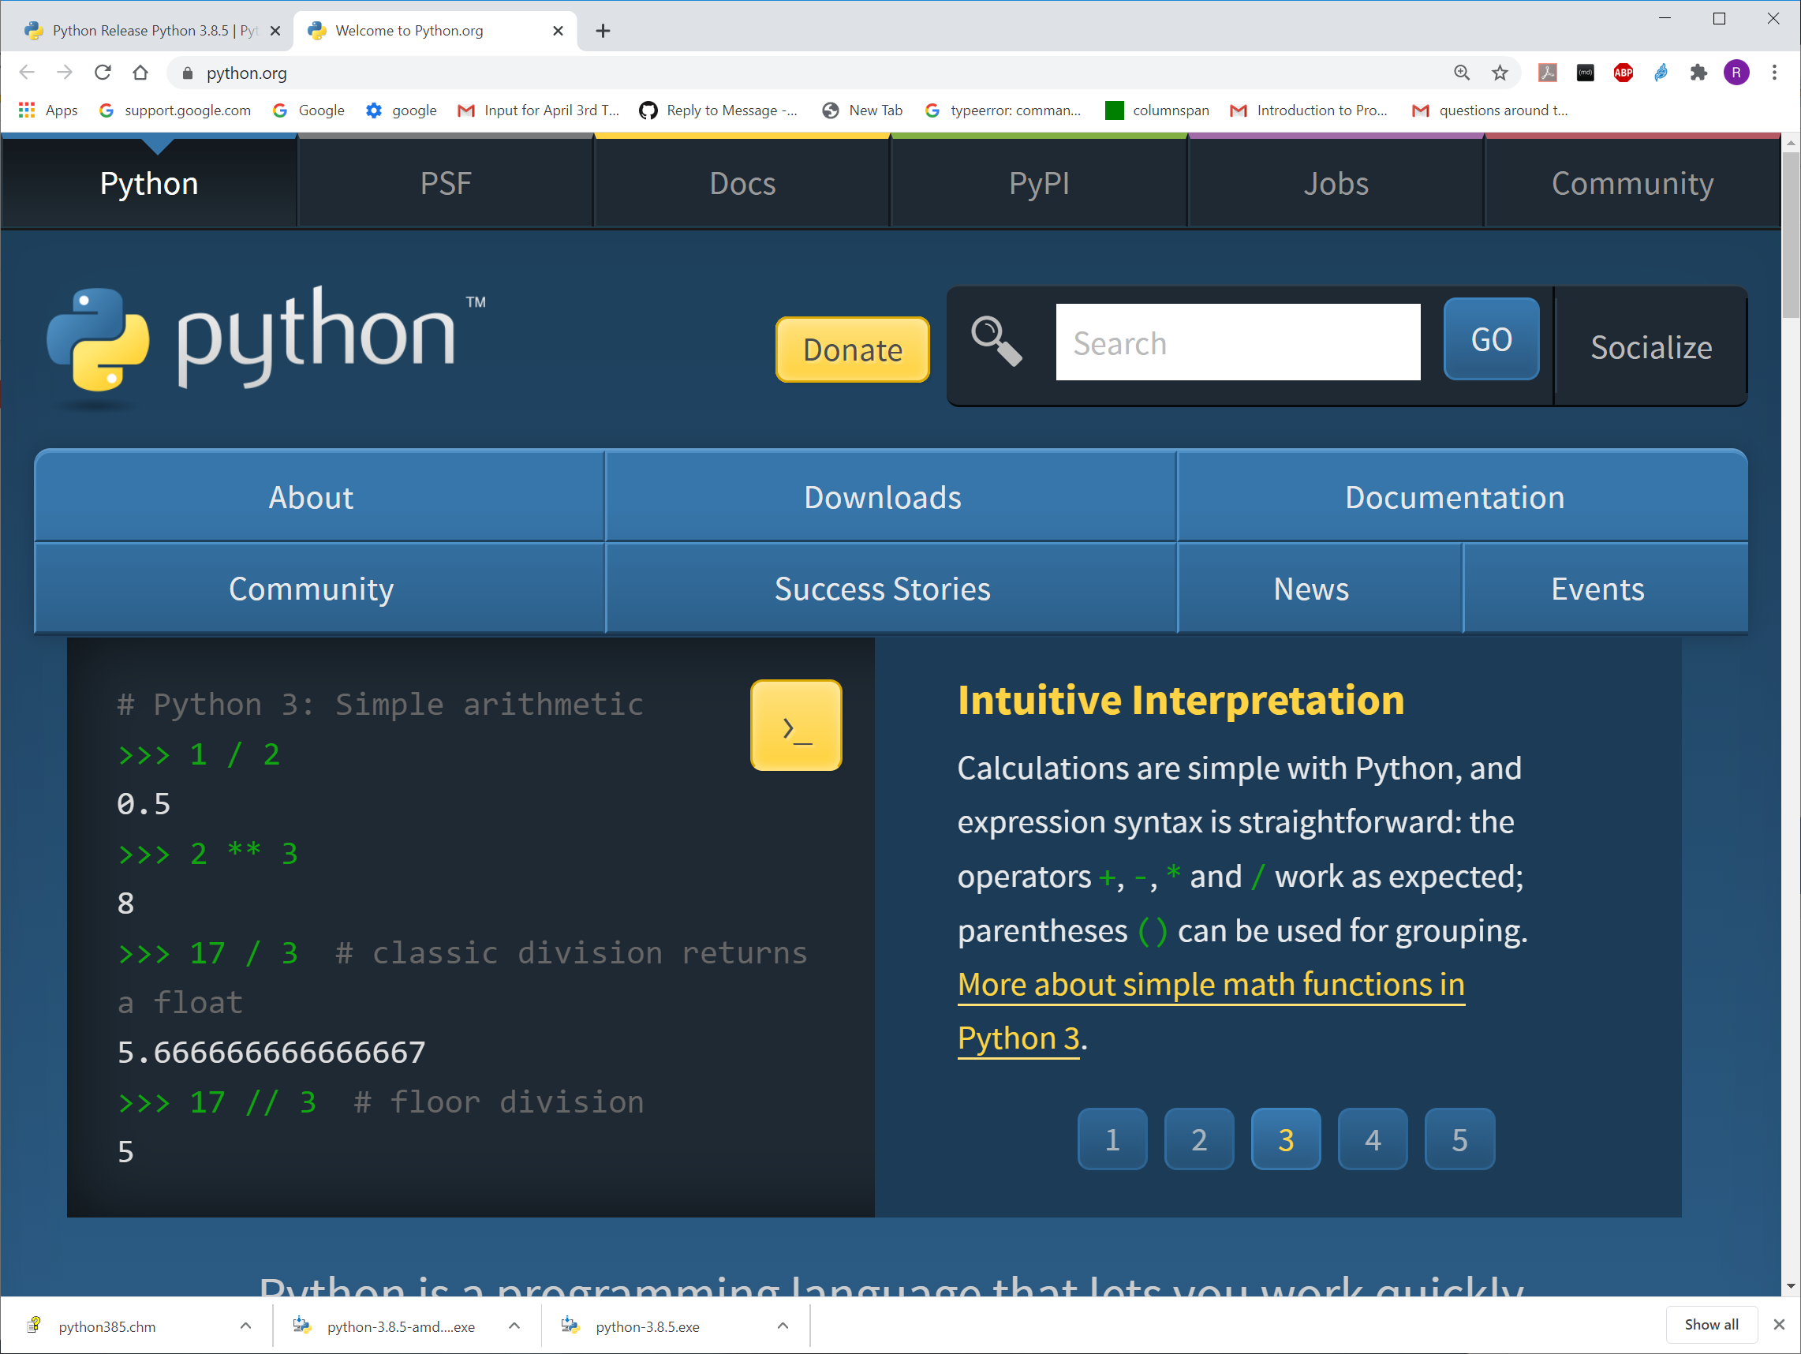

# Mouse over to Downloads

Giving the following:

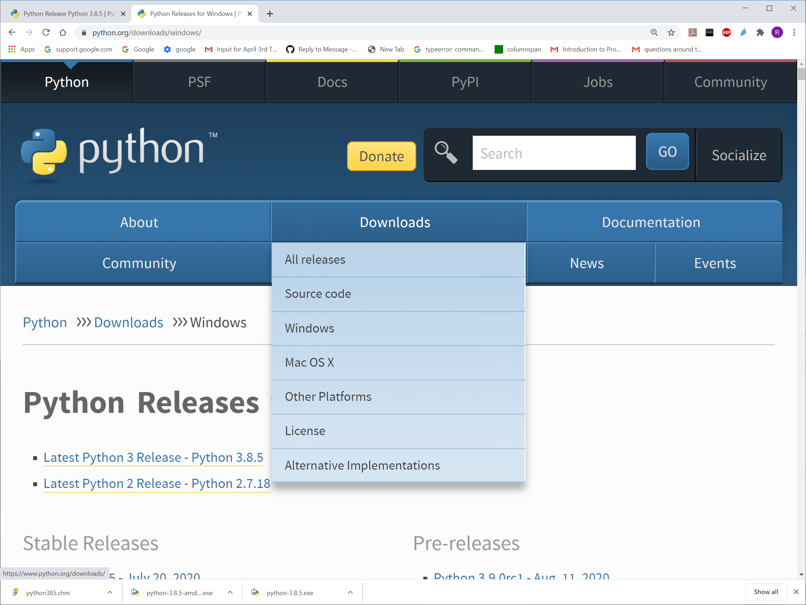

# Click on your computer's environment, e.g. Windows

Giving:

# Click on Python 3… [Latest Python 3 Release - Python 3.8.5](https://www.python.org/downloads/release/python-385/)

…

* Windows users
* The binaries for AMD64 will also work on processors that implement the Intel 64 architecture. (Also known as the "x64" architecture, and formerly known as both "EM64T" and "x86-64".)
* There are now "web-based" installers for Windows platforms; the installer will download the needed software components at installation time.
* There are redistributable zip files containing the Windows builds, making it easy to redistribute Python as part of another software package. Please see the documentation regarding [Embedded Distribution](https://docs.python.org/3.8/using/windows.html#embedded-distribution) for more information.

# Scroll down the page to "FILES"

Files

| **Version** | **Operating System** | **Description** | **MD5 Sum** | **File Size** | **GPG** |
| --- | --- | --- | --- | --- | --- |

# Click on the Version that best matches your computer/OS .e.g the following for windows on a 64-machine.

|  |  |  |  |  |  |  |  |  |  |  |  |  |  |  |  |  |  |  |  |  |
| --- | --- | --- | --- | --- | --- | --- | --- | --- | --- | --- | --- | --- | --- | --- | --- | --- | --- | --- | --- | --- |
| |  |  |  |  |  |  | | --- | --- | --- | --- | --- | --- | | [Windows x86-64 executable installer](https://www.python.org/ftp/python/3.8.5/python-3.8.5-amd64.exe) | Windows | for AMD64/EM64T/x64 | 0ba2e9ca29b719da6e0b81f7f33f08f6 | 27864320 | [SIG](https://www.python.org/ftp/python/3.8.5/python-3.8.5-amd64.exe.asc) | | |  |  |  |  |  |  | | --- | --- | --- | --- | --- | --- | | [Windows x86-64 executable installer](https://www.python.org/ftp/python/3.8.5/python-3.8.5-amd64.exe) | Windows | for AMD64/EM64T/x64 | 0ba2e9ca29b719da6e0b81f7f33f08f6 | 27864320 | [SIG](https://www.python.org/ftp/python/3.8.5/python-3.8.5-amd64.exe.asc) | | |  |  |  |  |  |  | | --- | --- | --- | --- | --- | --- | | [Windows x86-64 executable installer](https://www.python.org/ftp/python/3.8.5/python-3.8.5-amd64.exe) | Windows | for AMD64/EM64T/x64 | 0ba2e9ca29b719da6e0b81f7f33f08f6 | 27864320 | [SIG](https://www.python.org/ftp/python/3.8.5/python-3.8.5-amd64.exe.asc) | |

Downloaded file name should appear in lower left corner:

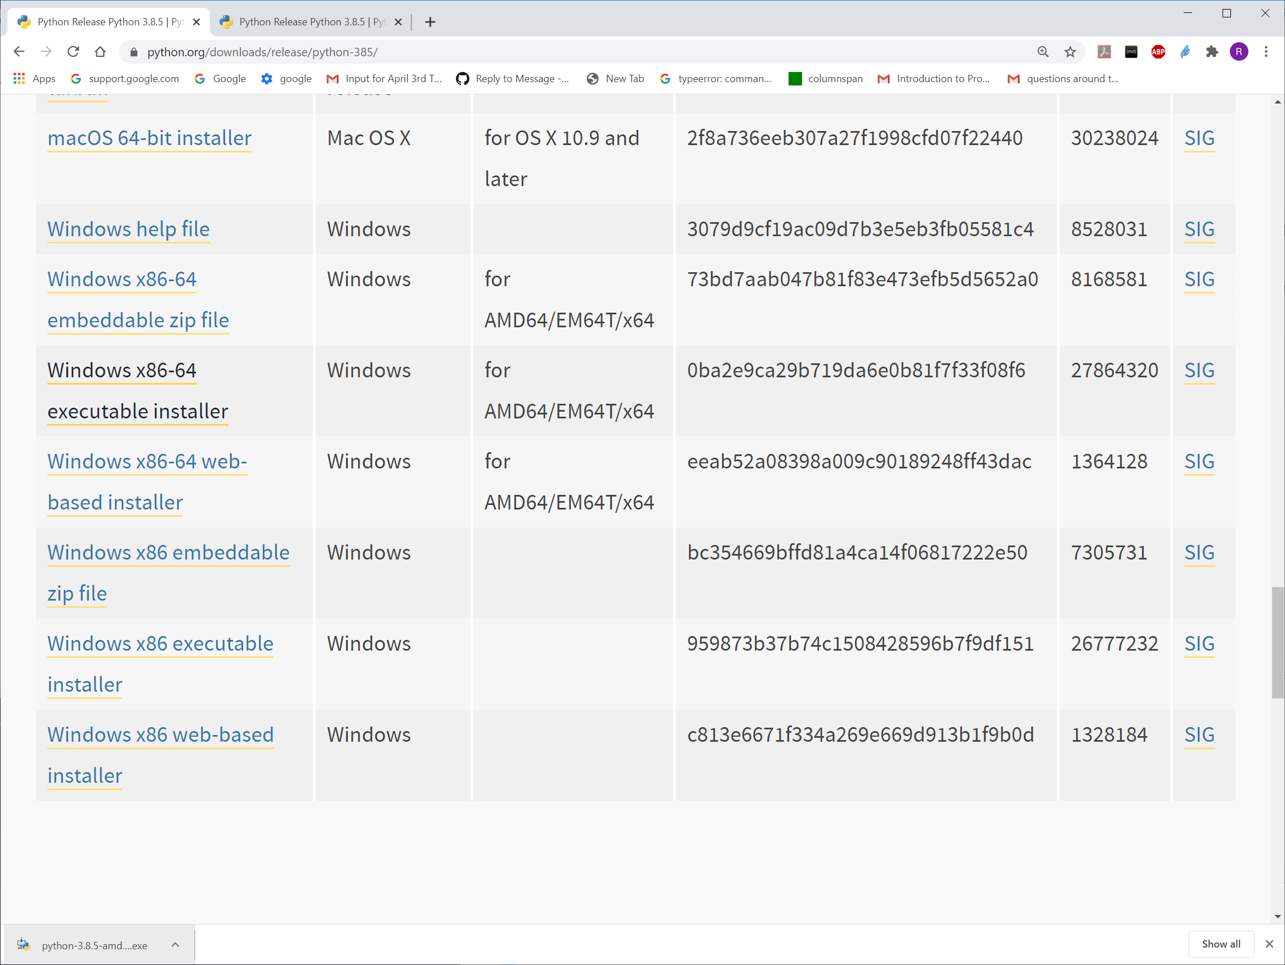

# Click on the Downloaded file name to get the following:

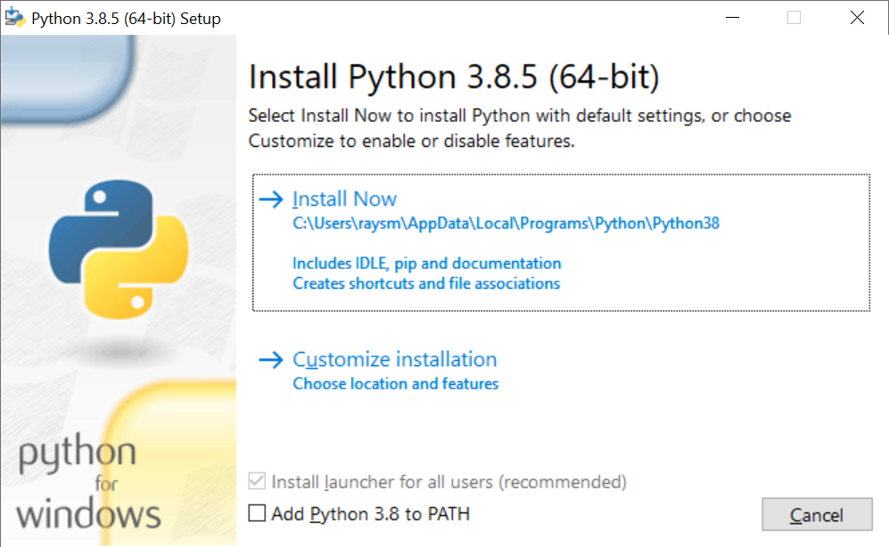

## If you don’t have python already installed, select Add Python … to PATH

# Click on "Install Now"

Producing a Setup Progress like this:

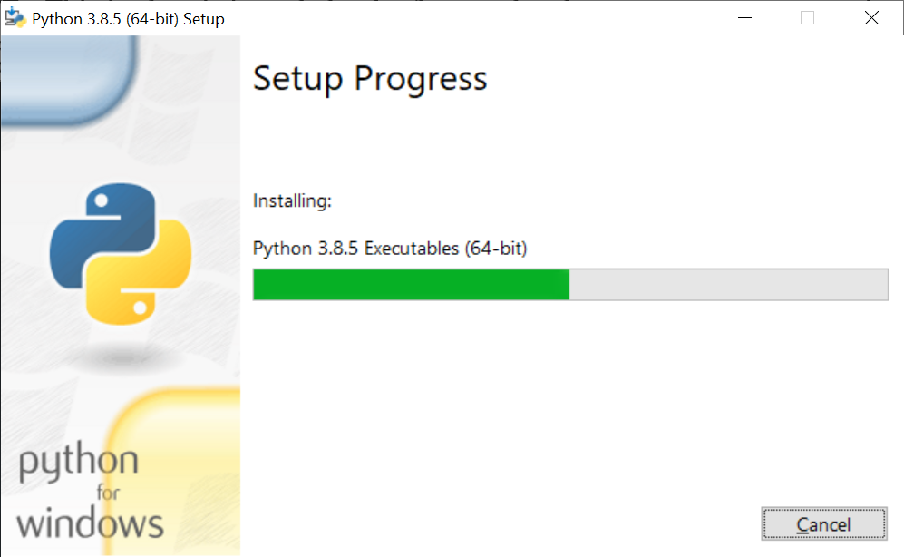

The setup, depending on your computer, should take a minute or so. At the end, the display should look something like the following:

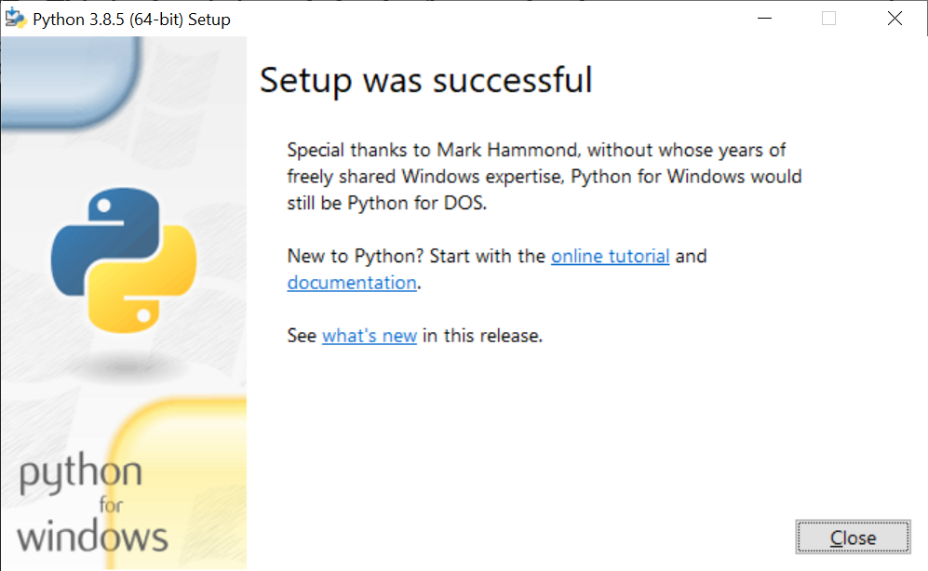

# Click Close to complete the installation.

# Check Installation (From mine on windows 10)

## Run IDLE : Start 🡺 Programs Python 3.8 🡺 IDLE

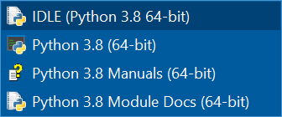

Creating Python Shell as follows:

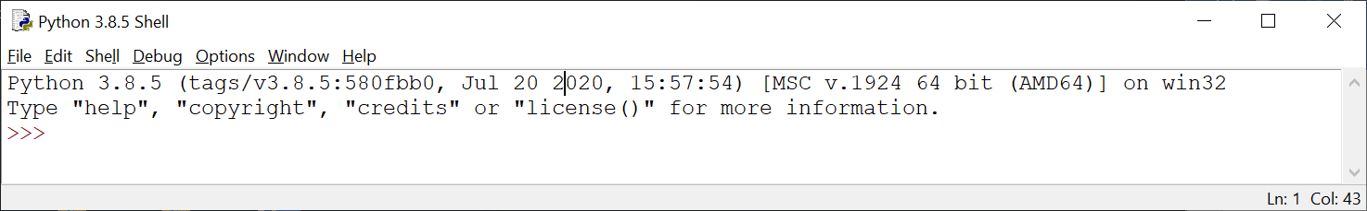

# In the Python shell, to the right of the ">>>" type some arithmetic statement, e.g., 1 + 1, then the ENTER key.

You should get something like this. Try a few more.

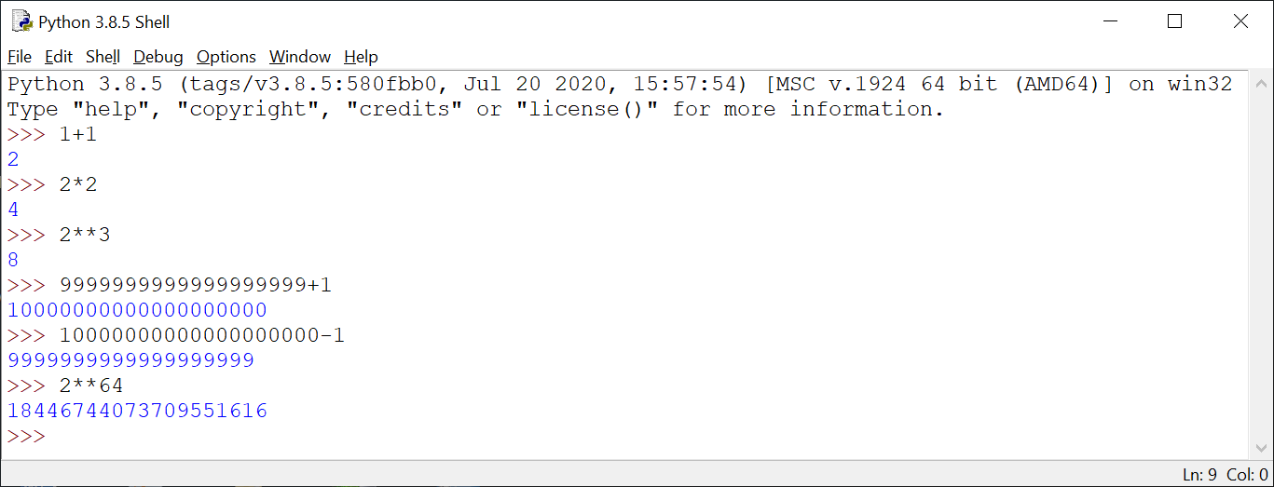

# Congratulations! You have installed Python.